CSSE463 Image Recognition

Lab 3 Edge Detector

Zesun Yang

[yangz@rose-hulman.edu](mailto:yangz@rose-hulman.edu)

December 10, 2017

1. **Whole-Matrix Operations on Images**

Given:

>>A = [1 2; 3 4]; B = [5 6; 7 8]

>>C = A * B; C=[19 22; 43 50]

>>C = A .* B; C=[5 12;21 32]

With the * operator, MATLAB does standard matrix multiplication. For example in this case, C(1,1)=1*5+2*7=19; C(1,2)=1*6+2*8=22; C(2,1)=3*5+4*7=43; C(2,2)=3*6+4*8=50.

With the .*operator, MATLAB does element-wise multiplication rather than matrix multiplication. It multiplies elements that are at the same matrix position. For example in this case, C(1,1)=1*5=5; C(1,2)=2*6=12; C(2,1)=3*7=21; C(2,2)=4*8=32.

1. **5x5 Matrix Filter (.m submitted to dropbox):**

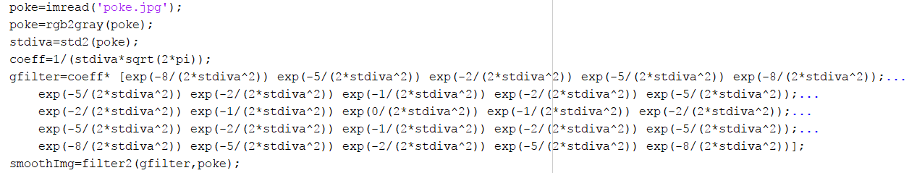

Figure 1. Guess filter



Figure 2. 5x5 guess filter and Gaussian filter meshes

Differences:

Overall, my 5x5 filter mesh has a significantly lower amplitude compare to the mesh of the real Gaussian filter. In addition to that, if I compare the difference between the max amplitude and the min amplitude of the two filters, it is apparent that the (max-min) amplitude value of the guess filter is very small compare to that of the real Gaussian filter.

When I apply both filter to my image, the guess filter provides a darker image, and has blurred many details compare to the real Gaussian filter.

1. **Sobel and Images** 
   1. Original Image (source: personal image)



* 1. Horizontal-edge

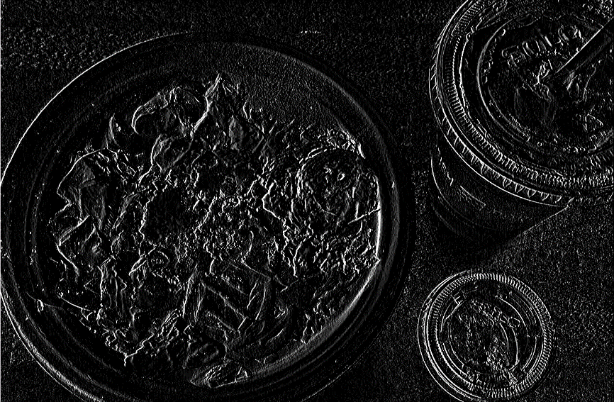

* 1. Vertical-edge

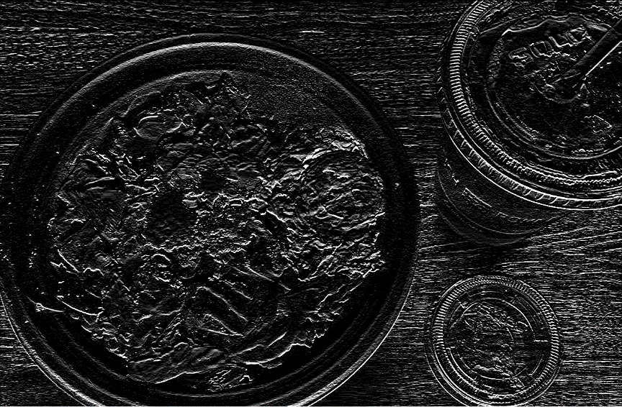

* 1. Sum

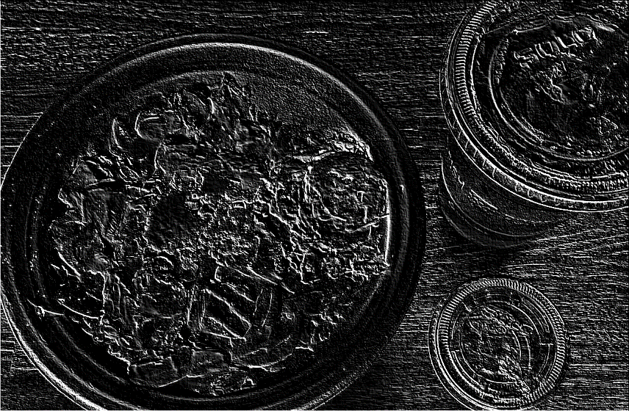

* 1. Raw magnitude

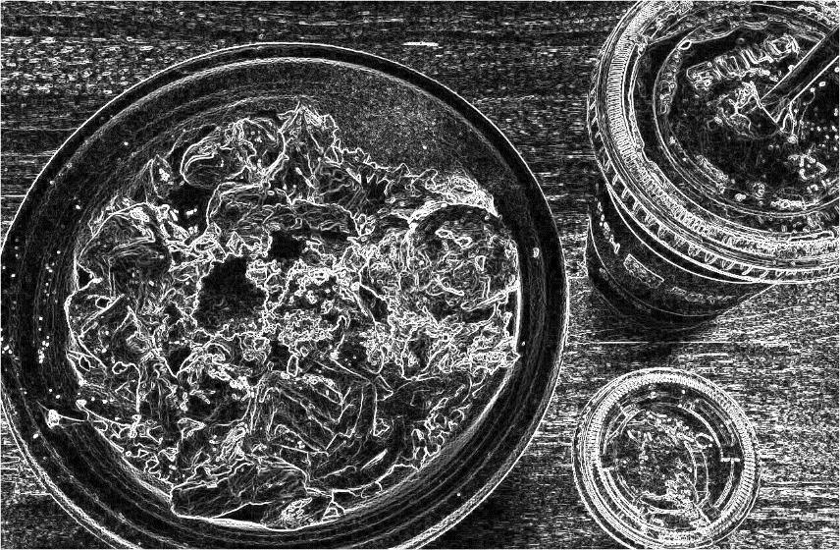

* 1. Raw direction

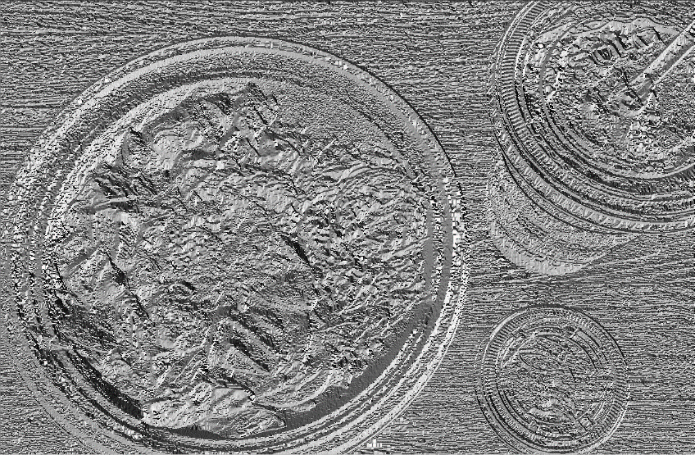

* 1. Direction with weak magnitude zeroed-out

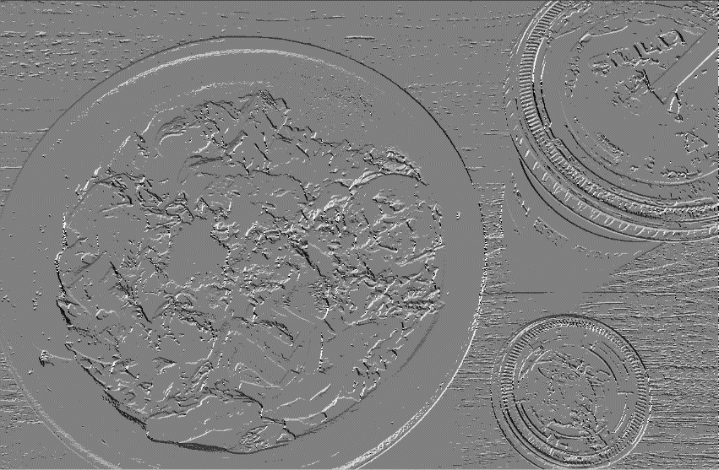

1. **Sobel function (.m submitted to dropbox):**

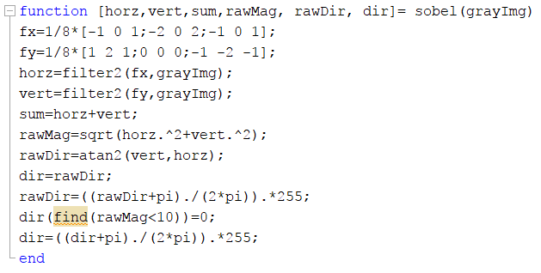

1. **A script that calls the sobel function n(.m submitted to dropbox):**

